Big Data

The word dawn means: the beginning of a phenomenon or period of time, especially one considered favourable.

Over the past 20 years, data has increased in a large scale in various fields. According to a report from International Data Corporation (IDC), in 2011, the overall created and copied data volume in the world was 1.8ZB, which has increased by nearly nine times within 5 years. Such figure will double at least every other 2 years in the near future.

Big data has attracted considerable interest from industry, academia, and government agencies. For example, issues on big data are often covered in public media, including The Economist, New York Times, and National Public Radio.

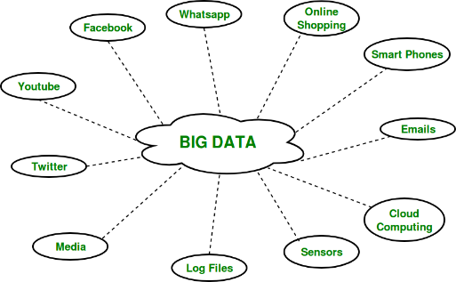

**Def:**

Big data refers to the datasets that could not be perceived, acquired, managed, and processed by traditional IT and software/hardware tools within a tolerable time.

In 2010, Apache Hadoop defined big data as “datasets which could not be captured, managed, and processed by general computers within an acceptable scope.

Big data is a collection of large datasets that cannot be processed using traditional computing techniques.

**Challenges:**

The challenge includes capturing, curating, storing, searching, sharing, transferring, analyzing and visualization of this data.

The three different formats of big data are:

* ***Structured:***Organised data format with a fixed schema. Ex: RDBMS
* ***Semi-Structured:*** Partially organized data which does not have a fixed format. Ex: XML, JSON
* ***Unstructured:*** Unorganized data with an unknown schema. Ex: Audio, video files, etc.

**Advantages of BD:**

* Cost Savings
* Better decision-making
* Better Sales insights
* Increased Productivity
* Improved customer service.

**5V’s of big data:**

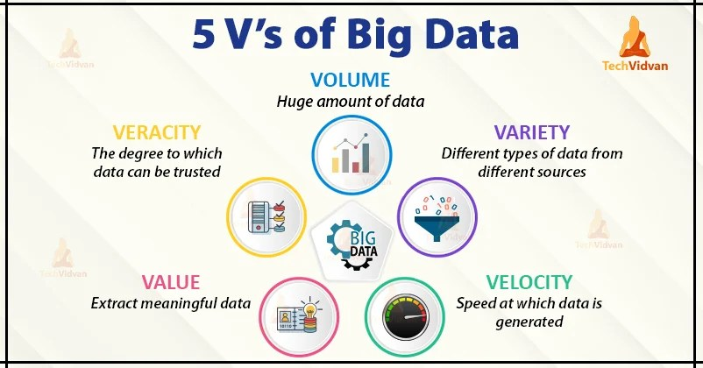

characteristics of Big Data:

**1. Volume:**

* The name ‘Big Data’ itself is related to a size which is enormous.
* Volume is a **huge amount of data**.
* To determine the value of data, size of data plays a very crucial role. If the volume of data is very large then it is actually considered as a ‘Big Data’. This means whether a particular data can actually be considered as a Big Data or not, is dependent upon the volume of data.
* Hence while dealing with Big Data it is necessary to consider a characteristic ‘Volume’.

**2. Velocity:**

* Velocity refers to the **high speed of accumulation of data.**
* In Big Data velocity data flows in from sources like machines, networks, social media, mobile phones etc.
* There is a massive and continuous flow of data. This determines the potential of data that how fast the data is generated and processed to meet the demands.
* *Example:* There are more than 3.5 billion searches per day are made on Google. Also, FaceBook users are increasing by 22%(Approx.) year by year.

**3. Variety:**

* It refers to **nature of data** that is structured, semi-structured and unstructured data.
* It also refers to heterogeneous sources.
* Variety is basically the arrival of data from new sources that are both inside and outside of an enterprise. It can be structured, semi-structured and unstructured.

**4. Veracity:**

* It refers to **inconsistencies and uncertainty in data**, that is data which is available can sometimes get messy and quality and accuracy are difficult to control.
* Big Data is also variable because of the multitude of data dimensions resulting from multiple disparate data types and sources.
* *Example:* Data in bulk could create confusion whereas less amount of data could convey half or Incomplete Information.

**5. Value:**

* After having the 4 V’s into account there comes one more V which stands for Value.
* Data in itself is of no use or importance but it needs to be converted into something valuable to extract Information. Hence, you can state that Value is the most important V of all the 5V’s.

**Big Data challenges :**

* ***Sharing and Accessing Data:***
  + Perhaps the most frequent challenge in big data efforts is the inaccessibility of data sets from external sources.
  + It include the need for inter and intra- institutional legal documents.
  + Accessing data from public repositories leads to multiple difficulties.
  + It is necessary for the data to be available in an accurate, complete and timely manner.
* ***Privacy and Security:***
  + It is another most important challenge with Big Data.
  + Most of the organizations are unable to maintain regular checks due to large amounts of data generation. However, it should be necessary to perform security checks and observation in real time because it is most beneficial.
  + There is some information of a person which when combined with external large data may lead to some facts of a person which may be secretive and he might not want the owner to know this information about that person.
* ***Analytical Challenges:***
  + There are some huge analytical challenges in big data which arise some main challenges questions like how to deal with a problem if data volume gets too large?
  + Or how to find out the important data points?
  + Or how to use data to the best advantage?
* ***Technical challenges:***
  + **Quality of data:**
    - When there is a collection of a large amount of data and storage of this data, it comes at a cost.
    - For better results and conclusions, Big data rather than having irrelevant data, focuses on quality data storage.
  + **Fault tolerance:**
    - Fault tolerance is another technical challenge and fault tolerance computing is extremely hard, involving intricate algorithms.
    - Nowadays some of the new technologies like cloud computing and big data always intended that whenever the failure occurs the damage done should be within the acceptable threshold that is the whole task should not begin from the scratch.
  + **Scalability:**
    - Big data projects can grow and evolve rapidly. The scalability issue of Big Data has lead towards cloud computing.
    - It leads to various challenges like how to run and execute various jobs so that goal of each workload can be achieved cost-effectively.
    - It also requires dealing with the system failures in an efficient manner.

**Big Data Tools:**

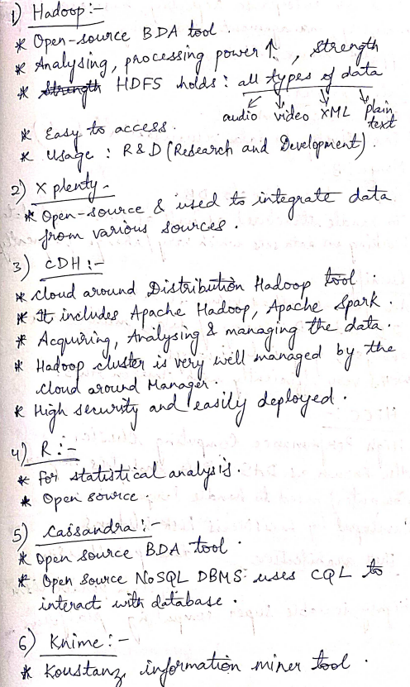

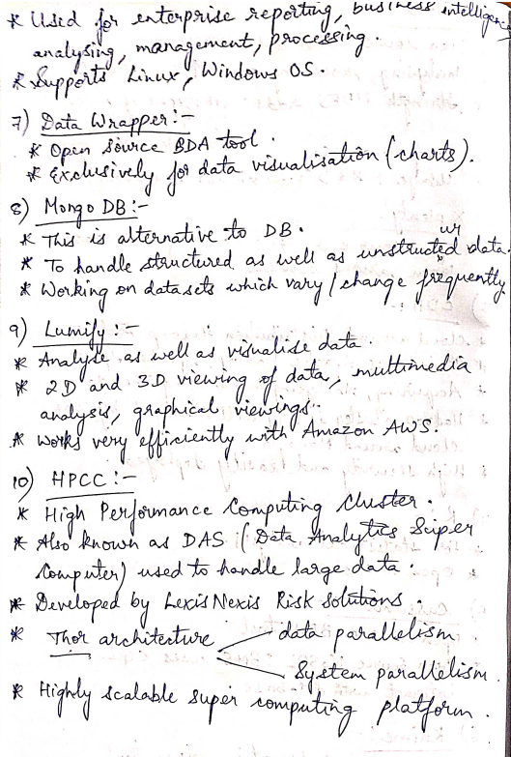

**Cloud:**

Cloud computing refers to the on demand availability of computing resources over internet. These resources includes servers, storage, databases, software, analytics, networking and intelligence over the Internet and all these resources can be used as per requirement of the customer. In cloud computing customers have to pay as per use. It is very flexible and can be resources can be scaled easily depending upon the requirement. Instead of buying any IT resources physically, all resources can be availed depending on the requirement from the cloud vendors. Cloud computing has three service models i.e [Infrastructure as a Service (IaaS), Platform as a Service (PaaS) and Software as a Service (SaaS)](https://www.geeksforgeeks.org/cloud-based-services/amp/).

**Examples** of cloud computing vendors who provides cloud computing services are Amazon Web Service (AWS), Microsoft Azure, Google Cloud Platform, IBM Cloud Services etc.

**Characteristics of Cloud Computing :**

* On-Demand availability
* Accessible through a network
* Elastic Scalability
* Pay as you go model
* Multi-tenancy and resource pooling.

**Advantages of Cloud Computing :**

* Back-up and restore data
* Improved collaboration
* Excellent accessibility
* Low maintenance cost
* On-Demand Self-service.

**Disadvantages of Cloud Computing :**

* Vendor lock-in
* Limited Control
* Security Concern
* Downtime due to various reason
* Requires good Internet connectivity.

**Difference between Big Data and Cloud Computing :**

|  |  |  |
| --- | --- | --- |
| **S.No.** | **BIG DATA** | **CLOUD COMPUTING** |
| 01. | Big data refers to the data which is huge in size and also increasing rapidly with respect to time. | Cloud computing refers to the on demand availability of computing resources over internet. |
| 02. | Big data includes structured data, unstructured data as well as semi-structured data. | Cloud Computing Services includes Infrastructure as a Service (IaaS), Platform as a Service (PaaS) and Software as a Service (SaaS). |
| 03. | Volume of data, Velocity of data, Variety of data, Veracity of data, and Value of data are considered as the 5 most important characteristics of Big data. | On-Demand availability of IT resources, broad network access, resource pooling, elasticity and measured service are considered as the main characteristics of cloud computing. |
| 04. | The purpose of big data is to organizing the large volume of data and extracting the useful information from it and using that information for the improvement of business. | The purpose of cloud computing is to store and process data in cloud or availing remote IT services without physically installing any IT resources. |
| 05. | Distributed computing is used for analyzing the data and extracting the useful information. | Internet is used to get the cloud based services from different cloud vendors. |
| 06. | Big data management allows centralized platform, provision for backup and recovery and low maintenance cost. | Cloud computing services are cost effective, scalable and robust. |
| 07. | Some of the challenges of big data are variety of data, data storage and integration, data processing and resource management. | Some of the challenges of cloud computing are availability, transformation, security concern, charging model. |
| 08. | Big data refers to huge volume of data, its management, and useful information extraction. | Cloud computing refers to remote IT resources and different internet service models. |
| 09. | Big data is used to describe huge volume of data and information. | Cloud computing is used to store data and information on remote servers and also processing the data using remote infrastructure. |
| 10. | Some of the sources where big data is generated includes social media data, e-commerce data, weather station data, IoT Sensor data etc. | Some of the cloud computing vendors who provides cloud computing services are Amazon Web Service (AWS), Microsoft Azure, Google Cloud Platform, IBM Cloud Services etc. |

**IoT(Internet of Things):**

The Internet of Things (IoT) describes the network of physical objects—“things”—that are embedded with sensors, software, and other technologies for the purpose of connecting and exchanging data with other devices and systems over the internet.

IoT Architecture:

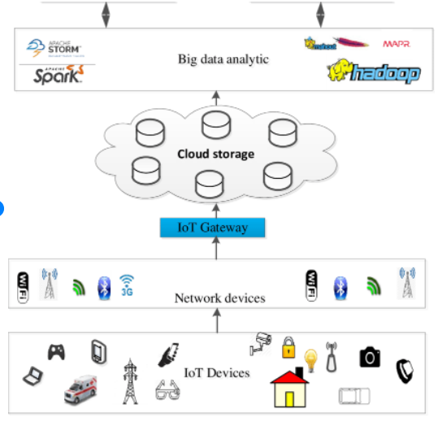 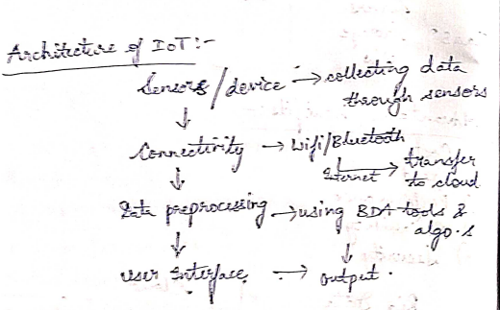

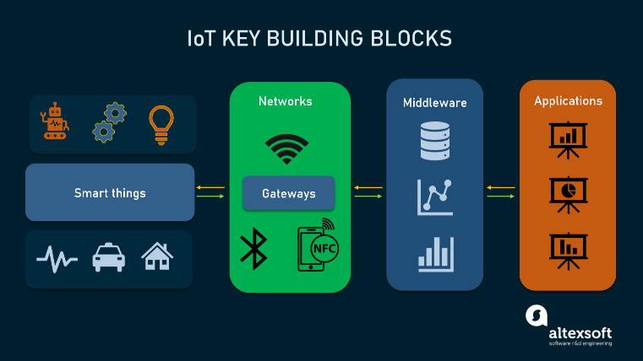

These elements make up the backbone of any IoT system upon which effective, multi-layered architecture can be developed. Most commonly, these layers are:

* the **perception layer** hosting smart things;
* the **connectivity or transport layer** transferring data from the physical layer to the cloud and vice versa via networks and gateways;
* the **processing layer** employing IoT platforms to accumulate and manage all data streams; and
* the**application layer** delivering solutions like analytics, reporting, and device control to end users.

Differences between IoT and Big Data.

| No | IOT | BIG DATA |
| --- | --- | --- |
| 1 | IoT is a global system of interrelated computing devices that are able to sense, collect, and exchange data over the Internet. | Big Data is described as large sets of data generated from a variety of sources that are so large to process using traditional techniques. |
| 2 | The concept is to provide interconnection between devices to create a smart environment thereby making machines smart enough to bypass human intermediaries. | The concept is to find insights in new and emerging types of data and content that lead to better decisions and strategic business moves. |
| 3 | IoT collects, analyzes, and processes data streams in real-time without any delay to make control decisions in an effective manner. | The data streams are not subjected to processing real-time and there is a delay between when the data is collected and when it is processed. |
| 4 | IoT involves analyzing machine-generated data such as sensors in home appliances and so on. | Big Data deals with human-generated data such as social media usage, photos, and videos, etc |
| 5 | IoT is about simultaneously collecting and processing data to make real-time decisions. | Big data is more into collecting and accumulating huge data for analysis afterward. |
| 6 | Using IoT you can track and monitor assets like trucks, engines, HVAC systems, and pumps. You can correct problems as you detect them. | With big data, you can analyze all the information you have about failures and start to uncover the root causes. |

**Hadoop:**

[Big Data](https://www.edureka.co/blog/what-is-big-data/) and [Hadoop](https://www.edureka.co/blog/hadoop-tutorial/) are inter-related in a way that without the use of Hadoop, Big Data cannot be processed.

[Hadoop](https://www.edureka.co/blog/every-hadoop-component/) is an open-source software framework used for storing and processing Big Data in a distributed manner on large clusters of commodity hardware.

## **Big Data vs Hadoop:**

|  |  |  |
| --- | --- | --- |
| Features | Big Data | Hadoop |
| **Definition** | Big Data refers to a large volume of both structured and unstructured data. | Hadoop is a framework to handle and process this large volume of Big data |
| **Significance** | Big Data has no significance until it is processed and utilized to generate revenue. | It is a tool that makes big data more meaningful by processing the data. |
| **Storage** | It is very difficult to store big data because it comes in structured and unstructured form. | Apache Hadoop HDFS is capable of storing big data. |
| **Accessibility** | When it comes to accessing the big data, it is very difficult. | Hadoop framework lets you access and process the data very fast when compared to other tools. |

**Hadoop Architecture:**

The Hadoop Architecture Mainly consists of 4 components.

* MapReduce
* HDFS(Hadoop distributed File System)
* YARN(Yet Another Resource Framework)
* Common Utilities or Hadoop Common

### 1. MapReduce

MapReduce nothing but just like an Algorithm or a data structure that is based on the YARN framework.

The major feature of MapReduce is to perform the distributed processing in parallel in a Hadoop cluster which Makes Hadoop working so fast.

MapReduce has mainly 2 tasks which are divided phase-wise:

In first phase, **Map** is utilized and in next phase **Reduce** is utilized.

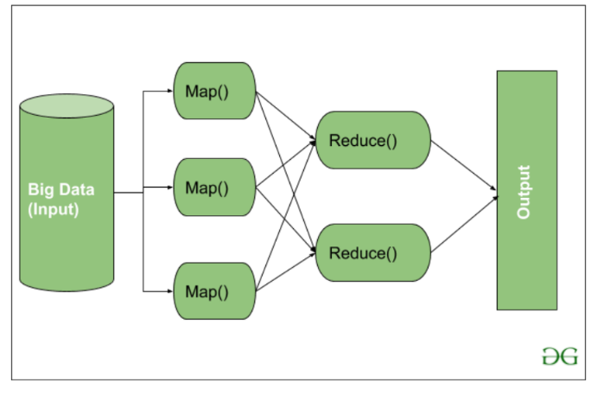

Here, we can see that the *Input* is provided to the Map() function then it’s *output* is used as an input to the Reduce function and after that, we receive our final output.

**2. HDFS**

HDFS in Hadoop provides Fault-tolerance and High availability to the storage layer and the other devices present in that Hadoop cluster. Data storage Nodes in HDFS.

* NameNode(Master)
* DataNode(Slave)

Data in HDFS is always stored in terms of blocks.

**NameNode:**

* NameNode works as a Master in a Hadoop cluster that guides the Datanode(Slaves).
* Namenode is mainly used for storing the Metadata i.e. the data about the data. Meta Data can be the transaction logs that keep track of the user’s activity in a Hadoop cluster.
* Meta Data can also be the name of the file, size, and the information about the location(Block number, Block ids) of Datanode that Namenode stores to find the closest DataNode for Faster Communication.
* Namenode instructs the DataNodes with the operation like delete, create, Replicate, etc.

**DataNode:**

* DataNodes works as a Slave.
* DataNodes are mainly utilized for storing the data in a Hadoop cluster, the number of DataNodes can be from 1 to 500 or even more than that. The more number of DataNode, the Hadoop cluster will be able to store more data. So it is advised that the DataNode should have High storing capacity to store a large number of file blocks.

**High Level Architecture Of Hadoop**

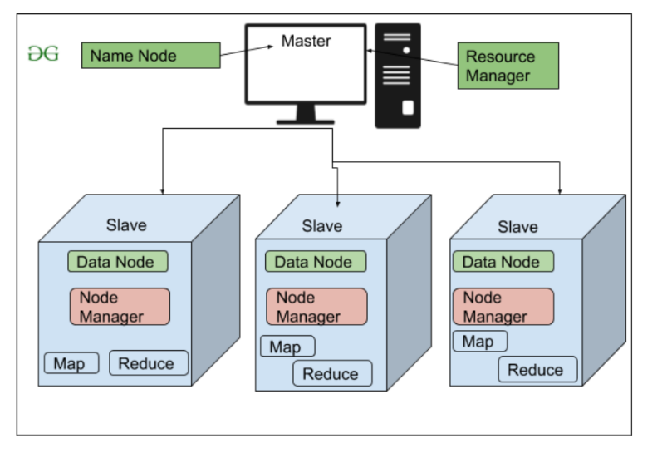

**3. YARN(Yet Another Resource Negotiator)**

YARN is a Framework on which MapReduce works.

YARN performs 2 operations that are Job scheduling and Resource Management.

The Purpose of Job schedular is to divide a big task into small jobs so that each job can be assigned to various slaves in a Hadoop cluster and Processing can be Maximized.

Job Scheduler also keeps track of which job is important, which job has more priority, dependencies between the jobs and all the other information like job timing, etc.

The use of Resource Manager is to manage all the resources that are made available for running a Hadoop cluster.

**Features of YARN**

* Multi-Tenancy
* Scalability
* Cluster-Utilization
* Compatibility

**4. Hadoop common or Common Utilities:** Hadoop common or Common utilities are nothing but java library and java files. These utilities are used by HDFS, YARN, and MapReduce for running the cluster.

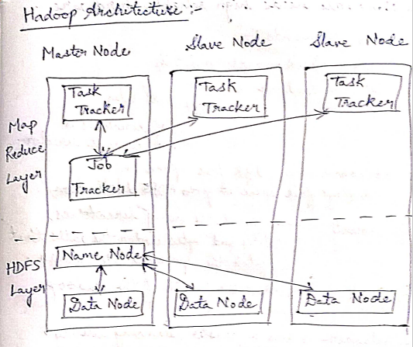

**Usage of Hadoop:**

Hadoop is used for:

* *Search* – Yahoo, Amazon, Zvents
* *Log processing* – Facebook, Yahoo
* *Data Warehouse* – Facebook, AOL
* *Video and Image Analysis* – New York Times, Eyealike

**Hadoop Commands:**

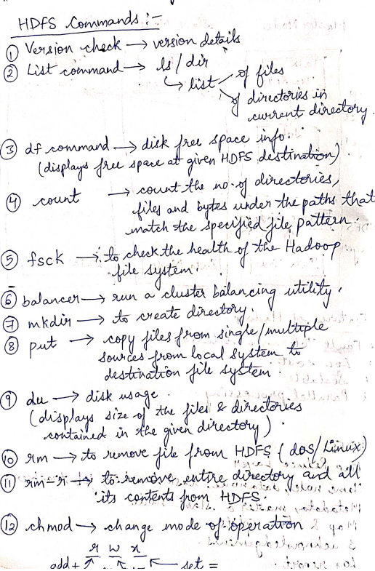

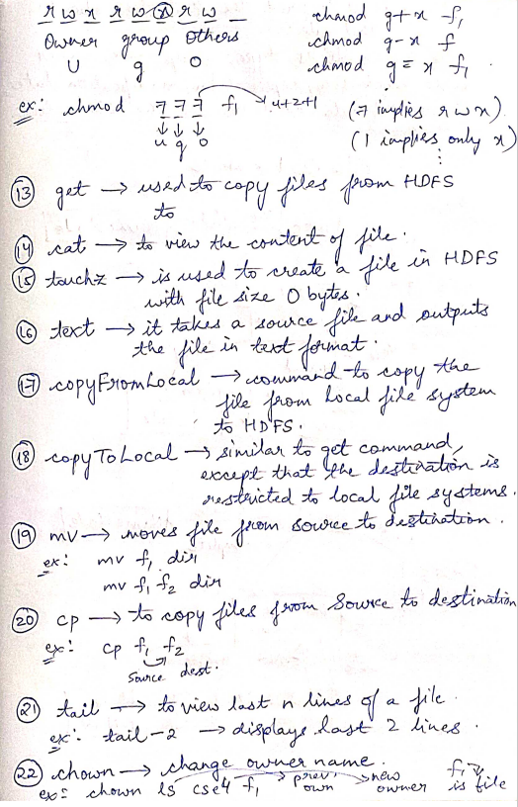

**Anatomy of File Read in HDFS**

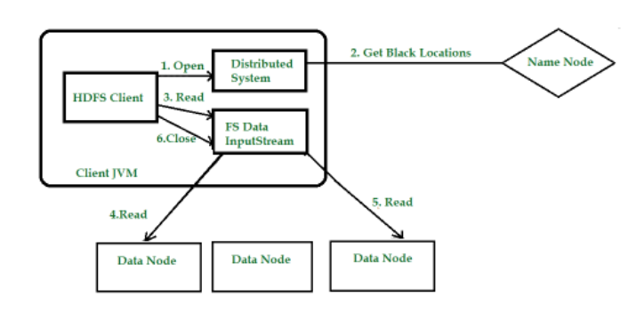

**Step 1:**The client opens the file it wishes to read by calling open() on the File System Object.

**Step 2:** Distributed File System( DFS) calls the name node, using remote procedure calls (RPCs), to determine the locations of the first few blocks in the file. For each block, the name node returns the addresses of the data nodes that have a copy of that block.

The DFS returns an FSDataInputStream to the client for it to read data from. FSDataInputStream in turn wraps a DFSInputStream, which manages the data node and name node I/O.

**Step 3:**The client then calls read() on the stream. DFSInputStream, which has stored the info node addresses for the primary few blocks within the file, then connects to the primary (closest) data node for the primary block in the file.

**Step 4:** Data is streamed from the data node back to the client, which calls read() repeatedly on the stream.

**Step 5:**When the end of the block is reached, DFSInputStream will close the connection to the data node, then finds the best data node for the next block. **Step 6:** When the client has finished reading the file, a function is called, close() on the FSDataInputStream.

### Anatomy of File Write in HDFS

### HDFS follows the Write once Read many times model. In HDFS we cannot edit the files which are already stored in HDFS, but we can append data by reopening the files.

### ****Step 1:**** The client creates the file by calling create() on DistributedFileSystem(DFS).

**Step 2:** DFS makes an RPC call to the name node to create a new file in the file system’s namespace. The name node performs various checks to make sure the file doesn’t already exist, if these checks pass, the name node prepares a record of the new file; otherwise, the file can’t be created and therefore the client is thrown an error i.e. IOException.

The DFS returns an FSDataOutputStream for the client to start out writing data to.

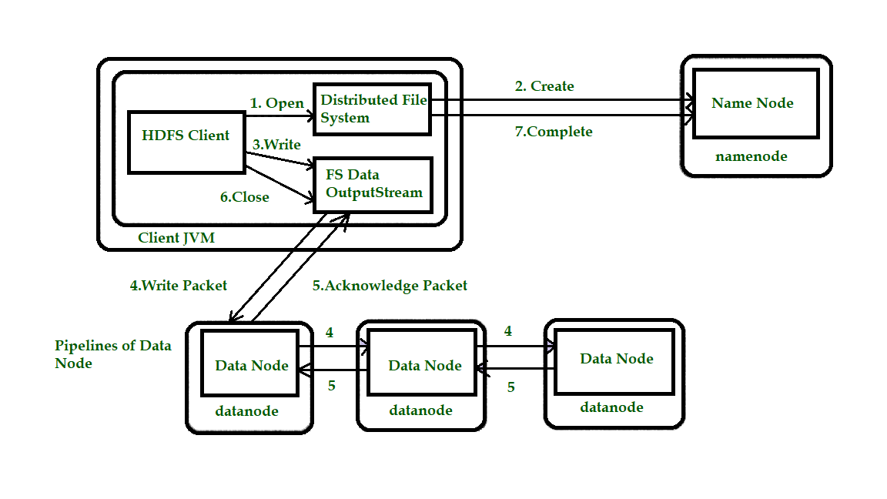

**Step 3:** Because the client writes data, the DFSOutputStream splits it into packets, which it writes to an indoor queue called the info queue. The data queue is consumed by the DataStreamer, which is liable for asking the name node to allocate new blocks by picking an inventory of suitable data nodes to store the replicas. The list of data nodes forms a pipeline, and here we’ll assume the replication level is three, so there are three nodes in the pipeline. The DataStreamer streams the packets to the primary data node within the pipeline, which stores each packet and forwards it to the second data node within the pipeline.

**Step 4:** Similarly, the second data node stores the packet and forwards it to the third (and last) data node in the pipeline.

**Step 5:**The DFSOutputStream sustains an internal queue of packets that are waiting to be acknowledged by data nodes, called an “ack queue”.

**Step 6:** This action sends up all the remaining packets to the data node pipeline and waits for acknowledgments before connecting to the name node to signal whether the file is complete or not.

**Hadoop Ecosystem:**

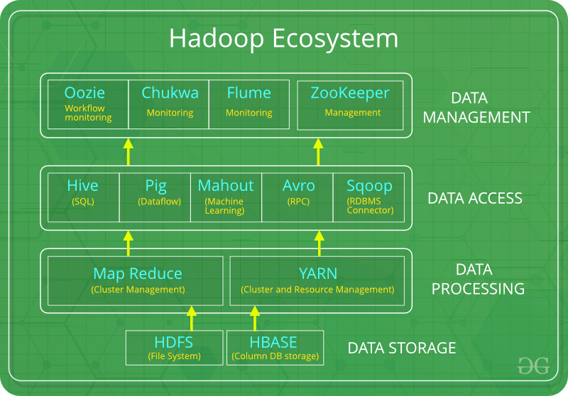

The components that collectively form a Hadoop ecosystem:

* HDFS: Hadoop Distributed File System
* YARN:  Yet Another Resource Negotiator
* MapReduce:  Programming based Data Processing
* Spark: In-Memory data processing
* PIG, HIVE: Query based processing of data services
* HBase: NoSQL Database
* Mahout, Spark MLLib: [Machine Learning](https://www.geeksforgeeks.org/machine-learning/)algorithm libraries
* Solar, Lucene: Searching and Indexing
* Zookeeper: Managing cluster
* Oozie: Job Scheduling

**NOTE**: HDFS, MapReduce and YARN already described above.

**PIG:**

 Pig was basically developed by Yahoo which works on a pig Latin language, which is Query based language similar to SQL.

* It is a platform for structuring the data flow, processing and analyzing huge data sets.
* Pig does the work of executing commands, After the processing, pig stores the result in HDFS.
* Pig Latin language is specially designed for this framework which runs on Pig Runtime. Just the way Java runs on the [JVM](https://www.geeksforgeeks.org/jvm-works-jvm-architecture/).
* Pig helps to achieve ease of programming and optimization and hence is a major segment of the Hadoop Ecosystem.

**HIVE:**

* HIVE performs reading and writing of large data sets. However, its query language is called as HQL (Hive Query Language).
* It is highly scalable as it allows real-time processing and batch processing both. Also, all the SQL datatypes are supported by Hive thus, making the query processing easier.
* Similar to the Query Processing frameworks, HIVE too comes with two components: *JDBC Drivers* and *HIVE Command Line*.
* JDBC, along with ODBC drivers work on establishing the data storage permissions and connection whereas HIVE Command line helps in the processing of queries.

**Mahout:**

* Mahout, allows Machine Learnability to a system or application.
* It provides various libraries or functionalities such as collaborative filtering, clustering, and classification which are nothing but concepts of Machine learning. It allows invoking algorithms as per our need with the help of its own libraries.

**Apache Spark:**

It’s a platform that handles all the process consumptive tasks like batch processing, interactive or iterative real-time processing, graph conversions, and visualization, etc.

* It consumes in memory resources hence, thus being faster than the prior in terms of optimization.
* Spark is best suited for real-time data whereas Hadoop is best suited for structured data or batch processing, hence both are used in most of the companies interchangeably.

**Apache HBase**:   
It’s a NoSQL database which supports all kinds of data. It provides capabilities of Google’s BigTable, thus able to work on Big Data sets effectively.

* At times where we need to search or retrieve the occurrences of something small in a huge database, the request must be processed within a short quick span of time. At such times, HBase comes handy as it gives us a tolerant way of storing limited data

**Lucene:**

These are the two services that perform the task of searching and indexing with the help of some java libraries, especially Lucene is based on Java which allows spell check mechanism, as well. However, Lucene is driven by Solr.

**Zookeeper:**

There was a huge issue of management of coordination and synchronization among the resources or the components of Hadoop which resulted in inconsistency, often. Zookeeper overcame all the problems by performing synchronization, inter-component based communication, grouping, and maintenance.

Zookeeper is an open-source project that provides services like maintaining configuration information, naming, providing distributed synchronization, etc.

**Oozie:**

Oozie simply performs the task of a scheduler, thus scheduling jobs and binding them together as a single unit.

There is two kinds of jobs .i.e Oozie workflow and Oozie coordinator jobs.

Oozie workflow is the jobs that need to be executed in a sequentially ordered manner. Oozie Coordinator jobs are those that are triggered when some data or external stimulus is given to it.

